To Year 13 Students - PLEASE READ VERY CAREFULLY!

I hope you have had a restful summer break and are looking forward to your second year.

Some Important Changes and Timetable
We are no longer using Student/Parent/Staff Advantage, we ported over to a new system (CEDAR) during the summer break. Parents/carers will receive an email with a link to create a CEDAR account once students are back in college full time. If they do not receive an email they should contact cedarparent@bilborough.ac.uk. Students will be able to access CEDAR using their Bilborough number and password, this will be going live shortly. See CEDAR access instructions at the end of this letter.

Only parent/carers can authorise student absences, instructions for reporting absences will be forwarded to your parent/carer in an email detailing how to access CEDAR (the new MIS system).

Mirrors have been added to some corridors in college to enable some students to navigate the corridors more easily.

Your timetable will be emailed to you and will include;
• Details of your subjects and Extended Studies option if applicable
• The name of your tutor. In some cases, we have had to change your tutor. However, your tutor from last year will still have responsibility for producing the first draft of your UCAS reference.

What should I do if I think my timetable is incorrect?
It is important we sort all timetable queries ASAP. We do not expect to be altering timetables once lessons start in earnest on 12th September. We might be able to sort simple timetable issues (e.g., missing subject) remotely. Please email enquiries@bilborough.ac.uk letting us know what the issue is, and we will see what we can do to resolve it. Please note we will only be able to address specific problems and will not be able to make timetable alterations to suit personal preferences for non-contact time. Any complicated issues which we cannot sort out by email might need to be resolved when you are in on the 6th of September.

Start of Year Arrangements

Year 13 Progression Day
You will need to attend college on Tuesday 6th September. We will be running a special timetable for the day (see below). All college buses are running as normal.

Subject Sessions
During the Progression Day you will attend a 1-hour lesson in all your subjects and collect work to complete remotely before the start of normal timetable on Monday 12 Sept. The rooms will be the same ones as your Tuesday/Wednesday lessons.
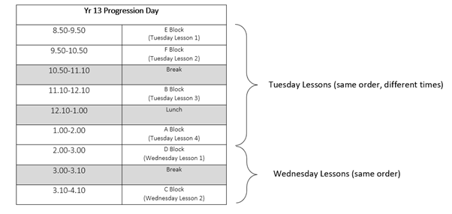
Please note:
- EPQ, Maths Studies and GCSE resit will not be running on Progression Day.
- Design Technology lesson will run at Bilborough College rather than at Fernwood on Progression Day. These will be in C0.03
Session with Dave Shaw
You will also be required to attend a short session with the Principal Dave Shaw in B3.7 during one of your free periods on Progression Day. Places for each session are limited so please try to attend as early as possible in the day. These sessions are compulsory and will be registered. The times of the sessions are below:
9am, 9:30am, 10am, 10:30am
11:15am, 11.45am
1pm, 1.30pm, 2pm, 2:30pm
Tutor Groups
Tutor sessions will not be running on Progression Day however tutors are providing a UCAS drop-in session which will run in Room B2.11 for any students who have not yet logged onto UCAS
Any Questions about Progression Day please email jill.hay@bilborough.ac.uk

What do I need to do between Progression Day and the start of full college timetable?
Full timetable begins on Monday 12th September.
Before this, you should:

- Update your UCAS form and personal statement
- Complete all work set by subject staff – transition work, summer holiday work and work set on Progression Day
- Organise and review all your work from Yr12
- Ensure you are fully prepared for the new academic year – stationary, folders, etc

Lanyard Reminder
All students and staff are required to wear Lanyards on the college premises. If you have lost your lanyard, new ones must be purchased. The cost is £3.50 for a new lanyard and photo ID.
Bus Information
College buses will run as normal on Progression Day and then from Monday 12th September. Payment for Bus Passes must be made on Wisepay.
Bursary Applications
Students living in households where the annual income is less than £27,500 (+£1000 for each additional dependent under 18) can and should apply for a College Bursary. This is granted on an annual basis, so need to apply again for 2022-2023. We recommend that all students apply for this if they fall into this category as we can support them with transport costs to and from college, laptop loan, essential course equipment, trips, and free meals in college.

I realise this is a long letter, many thanks for ploughing through to the end!

Looking forward to seeing you soon.

Best wishes
Michelle

