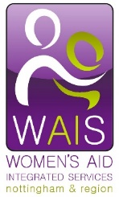
Women’s Aid Integrated Services
The Young Voices Project

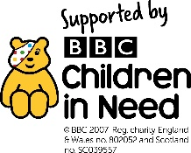
The Young Voices Project is a new three year project run by Women’s Aid Integrated Services. Launched in October, it will provide one to one support to children and young people aged 5 – 18 years who are living with or have experienced domestic violence or abuse (DVA) and live within Nottingham city.
Children and young people can be deeply affected by domestic abuse. They can be left, feeling traumatised, which can lead to anxiety depression, bed-wetting, problems at school and aggression. These distressing experiences can also lead to self-harm, drug and alcohol usage and addiction. Many are suffering in silence with little or no support.
Young Voices can provide 6-8 one to one sessions (up to 12 for more complex cases) and will support children and young people to:

- Understand what has happened in their home
- Understand that the DVA was not their fault
- Be able to express and explore their feelings
- Learn how to keep themselves safe
- Learn about healthy relationships
- Build self-esteem and resilience
- Reduce social isolation

Funded by Children in Need, the project will work in partnership with schools and other agencies in order to provide the best outcome and keep the child at the centre of the support. Support sessions will be delivered flexibly in schools, youth and community centres or if appropriate, in the family home.
For more information or to make a referral please contact the Young Voices Team duty desk Monday - Friday 9.00am - 5.00pm
T: 0115 9345044
E: youngvoices@wais.org.uk
W: www.wais.org.uk

