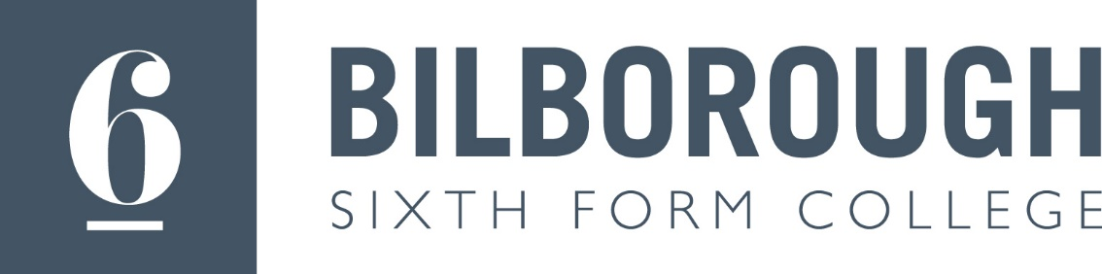

Safeguarding

If you have any concerns about yourself or a friend, you can contact a member of the Safeguarding Team.

Michelle Harvey - Designated Safeguarding Lead – telephone 0115 8515000 ex 1056 michelle.harvey@bilborough.ac.uk

Helen Ginns-Farrow - Safeguarding Officer - telephone 0115 8515000 ex 2016

helen.ginns-farrow@bilborough.ac.uk

Monique Norcliffe- Safeguarding Officer – telephone 0115 8515000 ext 1065

monique.norcliffe@bilborough.ac.uk

James Quested - Safeguarding Officer – 0115 8515000 ext 3204 james.quested@bilborough.ac.uk

Emma Collins - Safeguarding Officer – 0115 8515000 ext 2067

emma.collins@bilborough.ac.uk

Helen Smith – Safeguarding Officer – 0158515000 ext 2040

Helen.smith@bilborough.ac.uk

